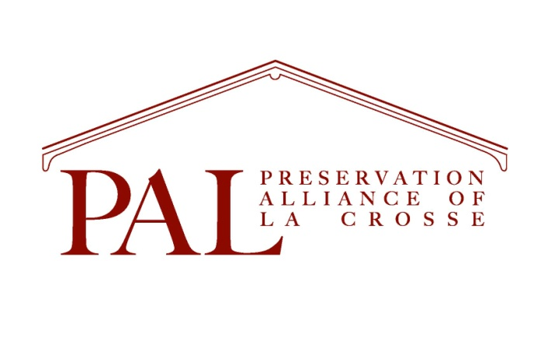
Ornament/Calendar Order Form  2022 Landmark Bldg. _____@ $25.00  2021 Charmant Hotel _____@ $25.00  2020 Gundersen Cottage _____ @ $25.00  2019 Magill Bank _____ @ $25.00  2018 Cargill Pettibone _____@ $25.00  2017 Public Library _____ @ $25.00  2016 Pearl Street West _____ @ $25.00  2015 Band Shell _____ @ $20.00  2014 #4000 at Grand Crossing _____@ $20.00  2013 Mississippi River _____@ $20.00  2012 St. Joseph Cathedral _____@ $20.00  2011 Grandad Bluff _____@ $20.00  2010 Freight House _____@ $20.00  2009 The Martindale House _____ @ $20.00  2008 Holy Trinity Church _____@ $20.00  2007 The Pump House _____@ $20.00  2006 King Gambrinus _____@ $20.00  2002 Pettibone Beach House _____@ $20.00  2001 The Ott House _____@ $15.00  2023 Calendar _____@ $15.00  Postage for 1 item $5.00  $1.00 for each additional ______@ $1.00  Total $__________________ | Checks Payable to PAL  Or  For Credit Card Users:  Visa, Mastercard, Discover, Am. Express  Card Number________________________  Expiration date_________/_____________  3 Digit Security Code_______________  Name as on Card__________________
Mail form to  PAL  119 King St.  La Crosse, WI 54601 | Email form to  preservationalliance@gmail.com

Name_____________________________________________________________
Address______________________________________________________________________________________________________________________________
Phone____________________ email________________________________

